**OreSat Deployable Antennas**

*End of Term Progress Report*

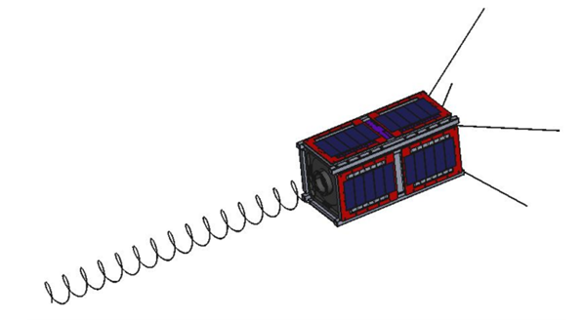

**Team Members**

*Calvin Young*

*Shivani Nadarajah*

*John George*

*Paijanne Jones*

*Justin Burris*

**Sponsors**

*Andrew Greenberg*

*Glenn LeBrasseur*

**ME 492**

*Gerald Recktenwald*

*March 21, 2018*

**1 Executive Summary**

**Project Objective**

Design, test, and manufacture the communication antennas and deployment systems for Oregon’s first satellite (OreSat) by June 29th, 2018, to be integrated into Portland State Aerospace Society’s (PSAS) main satellite, with help from the Oregon Space Grant Consortium (OSGC) to cover the associated $2000 projected cost.

**Project Overview**

Classified as a 2U (two unit), or the equivalent of two 10x10x10 cm cubes, OreSat has been developed in the standardized form factor known as a cubesat— a miniature satellite made from stacking units of 10 cm cubes.

After its validation and completion, OreSat will be delivered to the International Space Station (ISS) by NanoRacks, a space service provider, and then deployed into space by the crew of the ISS. Upon deployment, and including a lag time for safety, OreSat will activate and begin communication with ground base stations.

In order to conquer OreSat’s operational needs, two different deployable antenna systems are required— a canted turnstile array and an s-band helical. The first to deploy and communicate with ground, the canted turnstile array, is an omnidirectional antenna system that will allow PSAS to communicate with the satellite in any orientation and take control of its systems. Once OreSat’s attitude control system is initialized, the high-gain helical antenna will be deployed and oriented towards the ground stations in Oregon, allowing for high definition video to be streamed from its onboard cameras.

**Status and Achievements**

Design decisions were based on budget, regulatory requirements, reliability, and effectiveness of communication with ground stations.

The turnstile array went through several iterations of 3D printed prototypes in order to evaluate antenna stowage and deployment mechanism performance; selection has been narrowed to two concepts for the next phase of testing.

The helical antenna will take advantage of spring properties, allowing for stowage under elastic deformation, and deployment without an additional apparatus. In order to achieve a 16 dB output gain, a primary design constraint, the antenna geometry was optimized using MATLAB simulations. Several prototype antennas were created for radio frequency testing using copper, steel, and beryllium copper wire wrapped around a 3D printed guide mandrel.

**Milestones**

* 02 April Begin final design selection, refine CAD models
* 06 April Design of experiment and component testing
* 19 April Manufacture final design
* 07 May Initialize tests for vibration, electrical, and zero gravity conditions

**2 Client Requirements**

Initial interviews with the client were conducted to establish the scope and requirements of the deployable antenna project. In this meeting, the client emphasized line-item precedence, continued engagement in weekly meetings and discussions as well as continued updates with the client and associated PSAS team-members. These commitments have ensured progress, research, and prototype designs conform to designated specifications and coordinate with other parallel systems on the cube satellite.

In a weekly team meeting that included our faculty coach, as well as a weekly OreSat structural meeting, the following customer requirements have been refined and guide our design decision making:

* Turnstile antenna communicates with ground control to enable primary missions
  + Comes online quickly in order to enable basic communications
  + Radio frequency (RF) requirements redefined by client as RF testing advances
* Helical antenna communicates with handheld receivers to enable secondary missions
  + Has sufficient gain to reach handheld stations
  + Has a reasonably narrow bandwidth
* Both antenna systems deploy reliably and repeatedly
  + Turnstile antennas are arrayed at appropriate angles
  + Helical antenna deploys to appropriate pitch
  + Antennas can be shown to work on launch day with a high degree of certainty
* Both antenna systems can withstand the harsh launch and orbital environments
  + Antennas do not prematurely deploy
  + Antennas and deployment systems survive the vibration of launch vehicle
  + Deployment mechanisms function in low-earth orbit
  + Antennas do not deform excessively during attitude control
* Both complete antenna systems fall under material and financial budget limitations
  + Minimizes the mass of all subsystems
  + Stays within electrical constraints of power system
  + Uses a reasonably small portion of the financial budget
  + Fits within the designated area on the satellite
* Both complete antenna systems meet regulatory and service provider requirements
  + Complies with Cal Poly specifications for 2U CubeSat
  + Meets safety standards imposed by NASA

The client also assisted the team with assigning specific importance values so that design and manufacturing resources could be applied appropriately. Table 1 lists these importance values with the most important requirement being that the antennas must enable communication with the ground control stations. Repeatability and thus confidence in deployment is the second most important requirement identified.

**Table 1**: Importance values assigned to the client’s primary requirements.

|  |  |
| --- | --- |
| Communication with ground control | 11 |
| Communication with handheld receivers | 5 |
| Antenna systems deploy reliably, repeatedly | 10 |
| Systems withstand the harsh launch and orbit environments | 7 |
| Systems fall under budget limitations | 3 |
| Systems meet regulatory requirements | 7 |

**3 System Level Performance Metrics and Requirements**

A list of performance metrics have been outlined in Table 2. The turnstile antenna should take less than an hour to deploy in order to secure baseline communications with the ground station promptly. The helical antenna can be deployed within a week, allowing for careful and controlled decompression of the helix. Each antenna should be deployed in a stable, controlled manner to avoid additional, unnecessary oscillation.

Both antennas and deployment systems must be able to withstand the harsh environment of low Earth orbit, including: exposure to a hard vacuum (without outgassing), unmitigated radiation, and temperature cycles between -40 and +125 degrees Celsius. Both antenna systems must also be able to sustain the range of vibration and mechanical stress during launch without damage or premature deployment. Additionally, the systems must be able to operate after storage for up to six months.

The mechanical requirements imposed by the client are limited: the material chosen must comply with the electrical requirements of the antenna: the supporting and deployment structure must not interfere with the communications; the antennas must come to rest in the correct, predetermined orientation. Far more rigid are the mechanical specifications outlined by the CubeSat Design Specifications (CDS) from Cal Poly that must be adhered to by all CubeSats. Of primary concern are the spatial and dimensional limitations. The antennas, prior to deployment, must pack tightly within a small specified volume.

OreSat is an open-source, DIY project. All work shall be well-documented and publicly accessible. Failure is not an option.

**Table 2**: Performance metrics[1] for each primary requirement.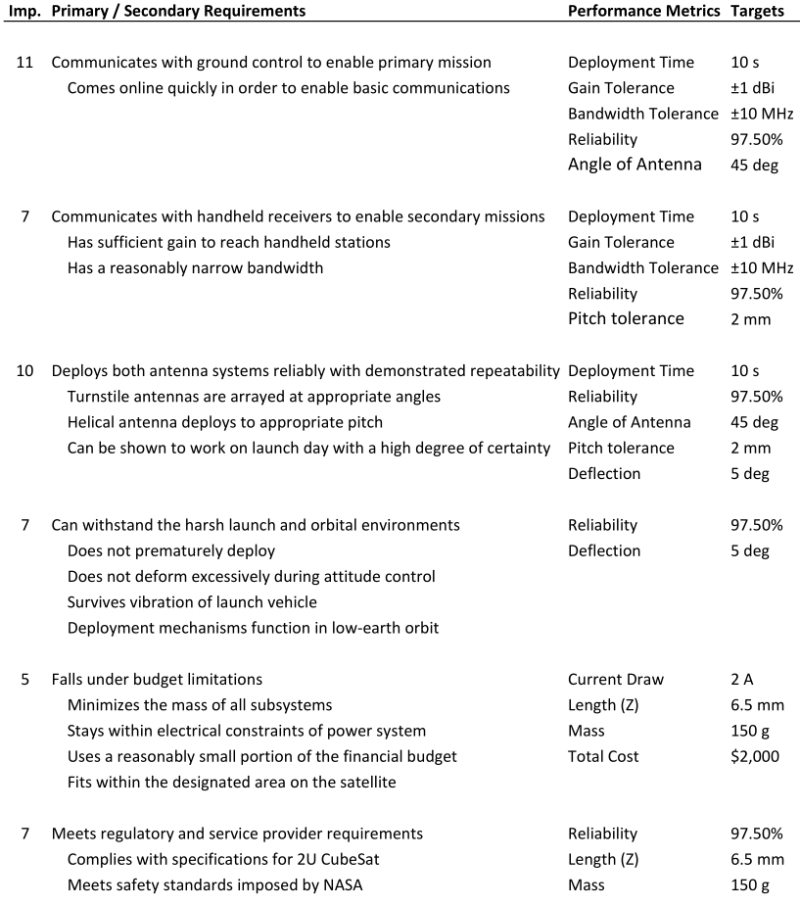

After identifying the primary, secondary, and performance-related requirements from the client interview process, we have correlated the primary needs with all associated performance measures and represented them graphically in a requirements matrix shown in Table 3. This has been done to illustrate and map the connection, rank of importance, and dependency of the various performance measures needed to successfully meet the established project guidelines.

**Table 3**: Requirements matrix linking client requirements to performance metrics.

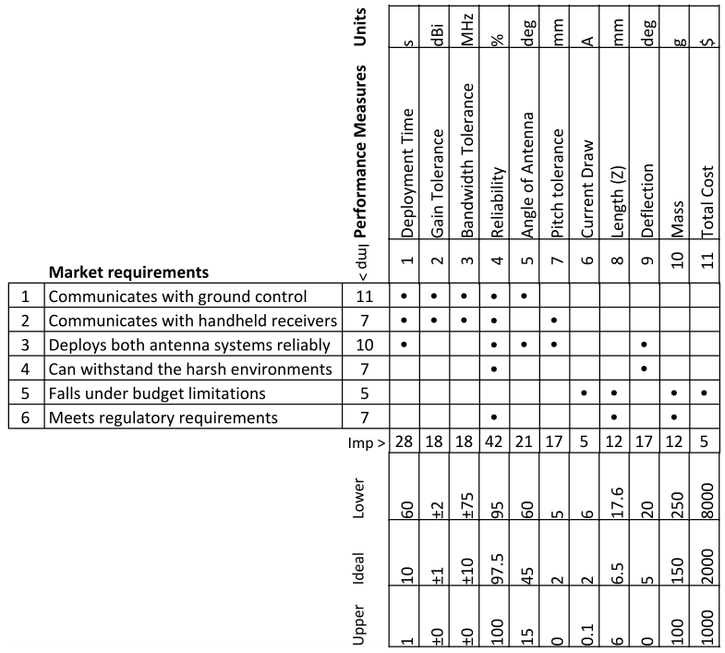

**4 Project Architecture**

OreSat requires two separate antennas to accomplish its primary mission to communicate with ground receivers. The first antenna, a turnstile array, consists of four straight monopoles fixed at 90 degree intervals. Each pole will be canted at a chosen angle between 15 and 60 degrees from the ground plane. This antenna transmits an omnidirectional signal, which enables initial contact with the ground station, then receives commands for satellite control. While stowed, the four poles of the turnstile array will be coiled around the antenna mount so that they spring back to their original orientation upon deployment. A guide ring may be used to help orient the stowed antenna poles.

The second antenna will be a high gain, s-band helical design. This highly directional transmitter will be used to stream video from the satellite cameras to handheld ground stations. It will be mounted and compressed until released by separation of a monofilament burnwire. Thin, lightweight tethers will keep the helix nominally compressed at its fully deployed state. The tension in these tethers will improve the lateral rigidity of the antenna structure.

The block diagram in Figure 1 depicts all main parts of the antenna systems and their general orientation. The deployment mechanism shown in yellow on each antenna is responsible for constraining the springs as well as releasing them.

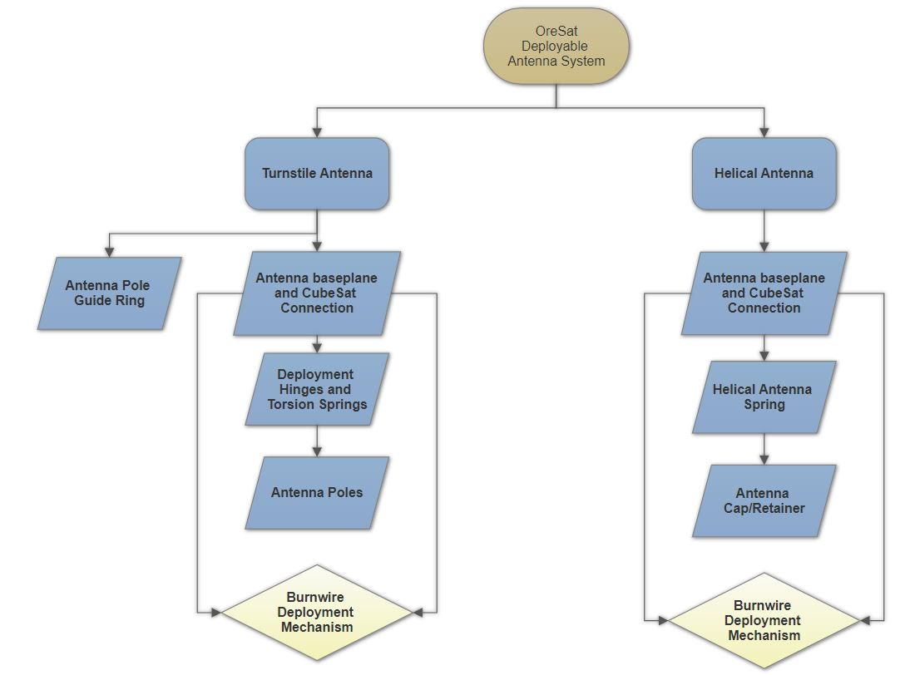

**Figure 1**: Structural decomposition block diagram illustrating system architecture. Arrows show physical flow and orientation of components starting from the satellite structure and flowing away from the structure.

**5 Subsystem Analysis**

**Helical Antenna**

A high-gain, directional link to the handheld ground stations, the helical antenna is essentially a large compression spring. Its fully-deployed length is nearly half a meter though it must be stored to a height of less than two centimeters. This necessitates the use of a fine gauge wire and a material that can withstand the strain of being fully compressed.

Initial design focused on the RF properties of the helix. While the style of antenna is fairly robust and accommodating of mechanical inaccuracies, it must be designed to communicate over a specific wavelength defined by the customer. The team dove into antenna design handbooks and ran MATLAB simulations on various designs in order to find one that fit within the mechanical constraints while meeting the electrical requirements. Conical and other variable-radius designs were explored for their advantage of compressing flat beyond the stacked length of a cylindrical helix. However, such designs created an unacceptably large bandwidth. It was ultimately determined that a sufficiently thin wire would compress to a sufficiently short stack.

An ideal antenna was designed using a MATLAB simulation and is described in Table 4.

**Table 4:** Properties of an ideal helical antenna.

|  |  |
| --- | --- |
| Frequency | 2.412 GHz |
| Mean Radius | 19.89 mm |
| Pitch Angle | 13.0 degrees |
| Number of Turns | 16 |

Wire thickness does not have an appreciable effect on the RF characteristics of the antenna which implies that the stacked height of the coil is the only driving constraint. Calculations[2] for beryllium copper showed that 24 AWG wire would not plastically deform when subjected to the strain; in the design documents it is shown that the maximum shear stress:

 

is not greater than the yield strength in torsion:

 

which indicates that the spring will return to its original length after being fully compressed. Analysis into stress-relaxation has not yet been completed though it should not be concerned as the current design has a factor of safety greater than 5. The design details and calculations are fully documented in a Jupyter notebook on the team’s GitHub repository[3].

Another consideration is the fact that we will tether the free end of the helix to the satellite structure. This will serve two purposes. First, it will damp the initial vibrations caused by the antenna’s release. Second, it will provide lateral rigidity to the otherwise tenuous structure in order to resist deformation caused by changes in momentum experienced during windup of the satellite’s reaction wheel system.

Progress has been made on the manufacturing front as well. After having mixed results with our attempts to make large helices on a lathe in the school’s machine shop, we decided to reach out to a local spring manufacturer. They generously provided our team with a tour of their facilities and offered tips on working with the lathe. Finally, they extended an offer to manufacture the spring if we find that we are unable to do so ourselves.

Successful helical prototypes have been made using another method which entails elastically wrapping a wire around a 3D printed mandrel. Since the wire is under considerable strain it is necessary to fix it in place which was accomplished using hot glue. These prototypes represent a perfectly formed helix and serves as a benchmark while performing RF tests. The team’s sponsor is responsible for performing the tests as he is the manager of the school’s RF testing chamber. As such, our prototypes are ready to be tested at his convenience.

**Turnstile Antenna**

The turnstile antenna’s general shape and deployed orientation was well defined from an electrical model created by the client. The main challenge of this antenna is the deployment system and selection of material for the poles. The turnstile consists of four poles oriented 90 degrees from each other which must be folded into the top of the satellite when stowed. A design goal is to keep the entire system under 6 mm tall when stowed. However, an additional 14 mm is available for negotiation if there is a demonstrated need for it. Several options are being considered for the final design. Testing in the spring term will determine which design is the most reliable.

Through research, it was found that a common CubeSat deployable antenna consists of a flat spring, similar to that found in a tape measure, that is rolled up into a stowed position - see Figure 2. The antenna poles are constrained by a burnwire until deployment at which point the properties of the flat spring cause the poles to unroll and take on the desired, straight, configuration. The main limitation of this design is compressibility. Compressing the springs to within 6 mm of height will plastically deform the flat springs and cause the antenna to fail meaning the design would require the entire 2 cm of space for the deployable system. The advantage of the design is that it’s very simple with no moving parts besides the springs, meaning there are fewer points of failure.

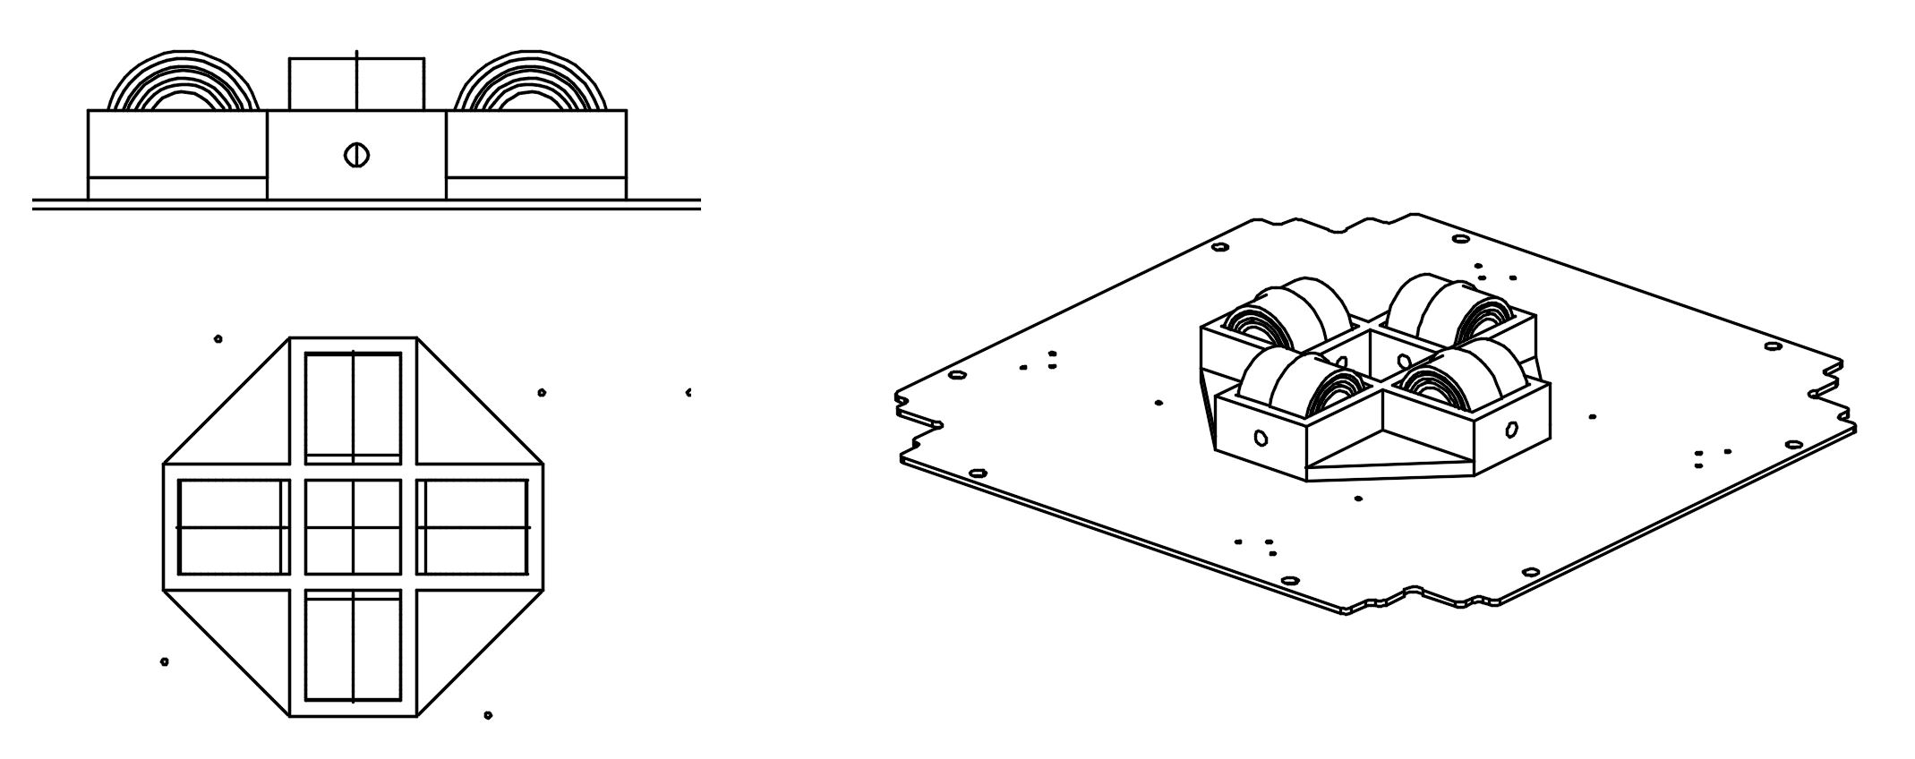

**Figure 2**: Flat rolled spring design prototype for initial design testing. Four flat springs are tightly rolled into cylinders and held in place using monofilament burnwire. The system is mounted on a mockup baseplate and shows no electrical connections.

In an attempt to meet the 6 mm dimension, we created an alternative design (see Figure 3) that was inspired by the NanoCom ANT430 UHF antenna[4] from GOMspace, a supplier of satellite components. The original conceptual prototype was designed using flat springs similar to the rolled spring design. Laying these springs flat and deploying them at angles using hinges, utilizing an additional torsion spring to drive the motion of the hinge, nearly kept the design under the 6 mm requirement. A circular guide ring was also designed to control the radius of curvature by preventing the poles from bending at a radius tight enough for plastic deformation to occur.

Upon visiting the local spring manufacturer and procuring several samples of material from them that could be used as deployable antenna poles, new pole materials are being considered. Validation of the material properties is ongoing with the main objective of confirming that the material will not plastically deform when stowed. Initial testing has yielded very promising results with the poles deploying straight after a relatively small amount of time being stowed. Additional testing and research into stress relaxation is required.

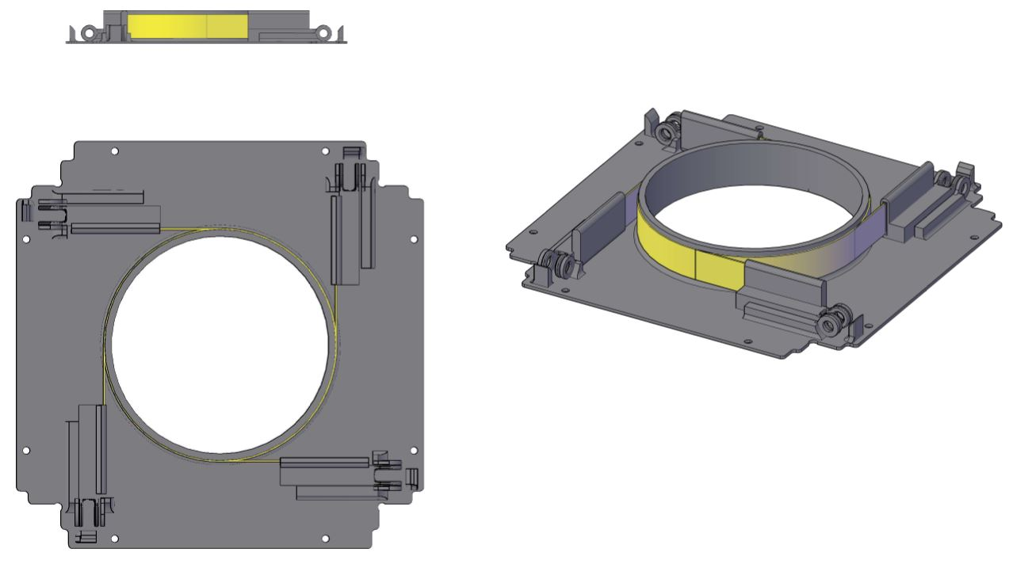

**Figure 3**: Current hinged deployable antenna design in CAD with flat spring or tape measure antenna poles. The model includes a place holder base plane and no electrical connections or cabling.

Final decisions and completed designs for the turnstile antenna design will be made in the first weeks of spring quarter in order to allow time for testing and design refinements.

**Burnwire Deployment System**

The most commonly used method for releasing deployables on small satellites consists of a resistive element being heated in order to melt through a monofilament line (known as a burnwire). Preliminary analysis began by researching existing and commercially available designs. Many solutions rely on complex mechanisms with moving parts and heavy components. OreSat is an open-source project that aims to use easily replicable designs that can be made with readily-available tools and materials. With that in mind, we focused on designing and testing a simpler mechanism.

While other systems include additional springs to provide tension on the burnwire in order to keep it in contact with the resistive element, we decided to rely on the spring force provided by the stowed antennas themselves. The helical antenna, modeled as a compression spring, provides a small force while the turnstile antenna keeps the line pulled taut.

As the burnwire system is used to deploy both antennas, it is necessary that it functions with utmost reliability. Dr. Gerald Recktenwald assisted the team by creating an analytical model[5] of the heat rate of a resistive nichrome wire. His analysis yielded equations for the heating rate as a function of both applied voltage and current.

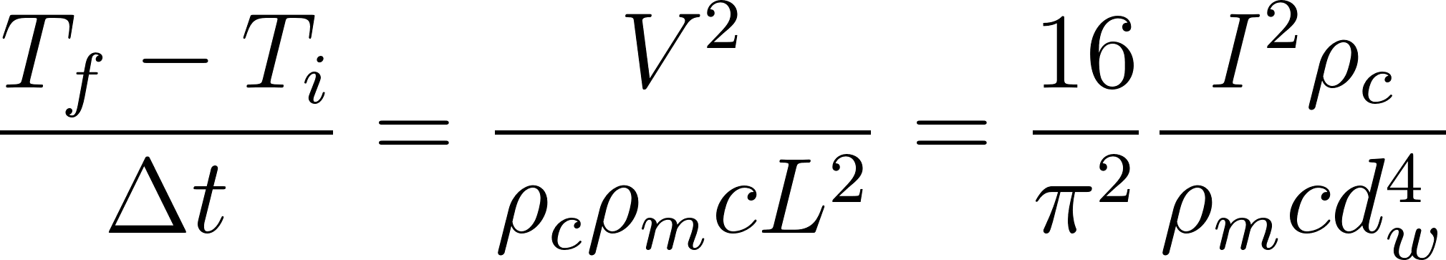 

Power as a function of wire length was also formulated.

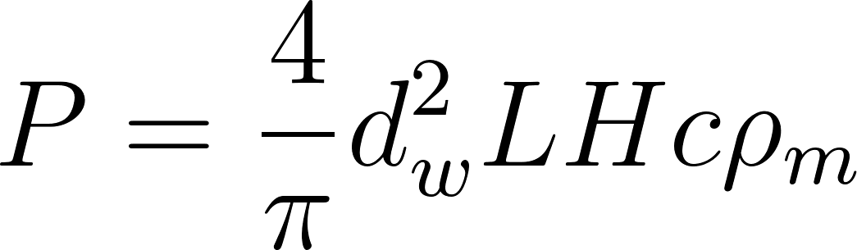 

The team went on to develop equations for the steady state temperature of the nichrome wire. Using the Stephan-Boltzmann Law again generates functions of both voltage and current:

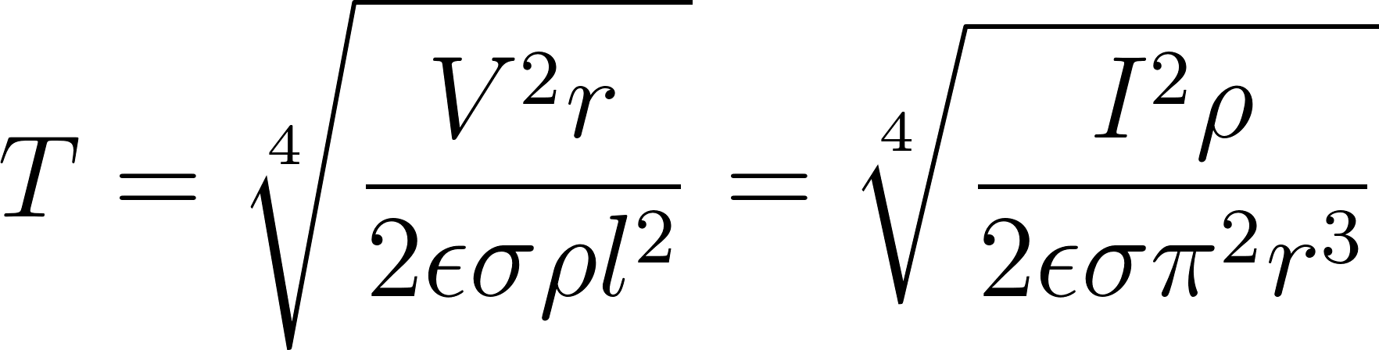 

Combining these equations provided a look at the range of values available for the design. We also wanted to take a look at through-hole resistors which might be used in place of resistive nichrome wire. Analytical investigations are more difficult due to the inhomogeneities of their design; detailed specifications sheets do not exist for commercially available resistors. Those limitations motivated the team to proceed with a series of experiments.

The experiment was designed to analyze three of the burnwire system’s key input variables: diameter of the monofilament, value of the resistor, and ambient pressure. In order to establish the connection between variables and distinguish the level of importance, the results are analyzed by looking at the total energy used during each experiment. This value also captures a number of other important parameters, including: current, voltage across the resistor, and time to failure. By understanding the sensitivity to each input variable and the interactions between them, the team will make well-informed decisions when designing the final flight system. The experimental setup is shown in Figures 4 with a detail of the burnwire shown in the appendix in Figure 3A.

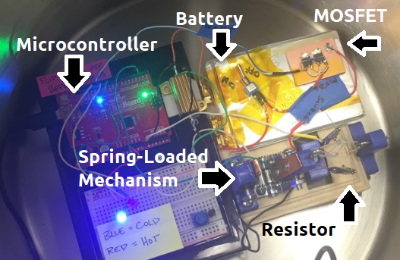

**Figure 4**: The entire testing apparatus is configured and placed in a vacuum chamber. The experiment is triggered via a serial connection which also transfers the data to be logged on an external computer.

A two-level, full factorial experiment was designed to measure the effects of each variable and any potential interactions between them on the outcomes of the experiment. With three factors (outlined in Table 5) being measured, this resulted in a 2^3 experiment with 8 runs per replicate.

**Table 5**: Two levels were used for each of the three factors in the experimental design.

|  |  |  |
| --- | --- | --- |
| **Factor** | **Low** | **High** |
| Pressure | 17 kPa | 101 kPa |
| Monofilament Diameter | 0.37 mm | 0.70 mm |
| Resistance | 2 Ω | 3 Ω |

Analysis of data for three experimental replicates show that the diameter of the monofilament is the most important factor for controlling both the time to cut and the energy requirement. Resistance is also a very important factor in the time to cut, though it does not have a significant impact on the total energy required to do so. Surprisingly, pressure does not seem to be an important factor. Figures 1A and 2A, found in the appendix, display the mean plots for each of these independent variables. Full analysis of the experimentation can be found in a report saved on the project’s GitHub repository[6].

**6 Plans for Future Work**

The bulk of next term will be dedicated to testing and refining the various subsystems in order to ensure a reliable, flight-ready product (Table 6). Selecting and manufacturing working prototypes will be the immediate focus for the team so that the testing can be performed.

We are in the process of setting up a suite of dynamics tests on a vibration table with a nearby commercial facility who has offered to donate time and resources to the project. Beyond that, the system will need to be tested in environmental conditions which will require extended time spent in a thermal vacuum chamber.

The dynamics of the deploying helical antenna are largely unknown and will need to be experimentally observed. This will be accomplished by loading the subsystem into the university’s Dryden Drop Tower where the antenna can be deployed in freefall. Over the course of 2.1 seconds the helix will extend and contract without the bending moment that would normally be caused by gravity.

The reliability of each antenna’s deployment system must be individually demonstrated. To that end, a suite of testing must be performed under a variety of conditions. This process will guide design decisions as each design is iterated upon and refined.

Finally, manufacturing of the flight articles will bring the project to a close. A number of extras will be created: one for the flight hardware, one for an engineering model, another for external testing, and a few more for spares.

**Table 6**: Gantt chart created for visual tracking of project tasks and their associated timelines.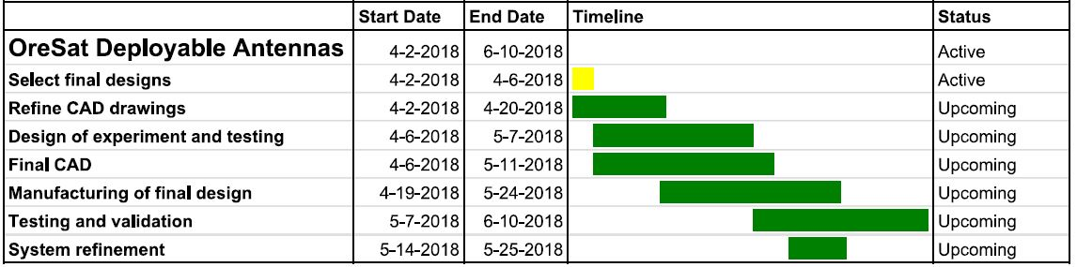

**7 Conclusion**

The team finds itself in a comfortable and actionable place at the end of the spring term. Much of the preliminary design work has yielded promising models and prototypes. Environmental reliability testing, our primary challenge, will determine the integrity of these designs and provide feedback for iterating on their weaknesses. Facilities are lined up to start running the antennas through the necessary tests and a healthy budget is in place to pay for them. Maintaining our current pace, we should have no difficulty in meeting the deadlines in place for the next few months. At this point there are no foreseeable obstacles that cannot be overcome by the resources available to us; we simply need to stay focused and on schedule.

**8 Appendix**

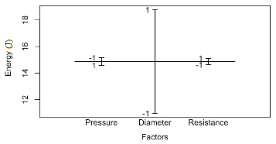

**Figure 1A**: Design of experiment mean plot with energy consumption as the dependent variable. Monofilament diameter is the most important variable. Both resistance and pressure are relatively unimportant factors.

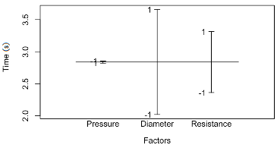

**Figure 2A**: Design of experiment mean plot with time to failure as the dependent variable. Pressure has little-to-no effect, while the diameter of monofilament and the heating element resistance both have a large effect on the experiment.

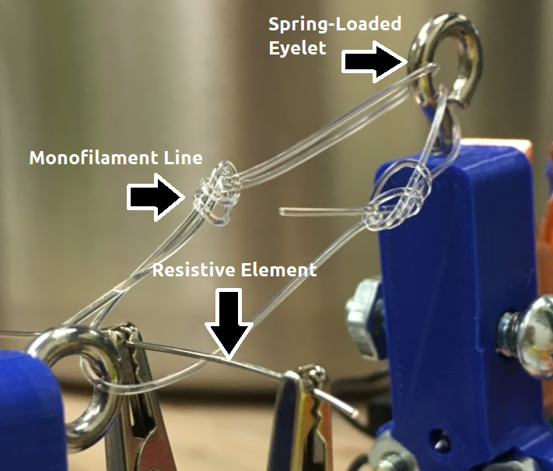

**Figure 3A**: Alligator clips hold a resistive element against a monofilament line. The spring-loaded eyelet on the right is used to send a signal to a microcontroller upon completion of the experiment.

1. Many values for the performance metrics are estimates derived from ongoing research and are subject to change and review.
2. Equations used in the spring design are taken from Shigley’s *Mechanical Engineering Design*.
3. https://github.com/oresat/oresat-structure/blob/master/Capstone/Helical_Antenna/
4. https://gomspace.com/UserFiles/Subsystems/datasheet/gs-ds-nanocom-ant430-32.pdf
5. http://web.cecs.pdx.edu/~gerry/class/ME492/pdf/burn_wire_model_slides.pdf
6. https://github.com/oresat/oresat-structure/blob/master/Capstone/Burnwire/